**Museums of Washington, D.C.**

Jordan Rivera

March 3rd, 2021

# Introduction

Washington, D.C., the capital of the United States, is home to all three branches of government, embassies of 174 foreign nations, and many international organizations. In addition to these things, D.C. is also known for its history. The city is filled with hundreds of monuments and museums. A majority of which are free to visit!

P​eak Washington, D.C. tourist season (mid-March to June) is fast approaching. If you are visiting the area you most likely want to know the answers to the following questions: 1) What are the highest rated museums in D.C.? 2) What museums are located closest to where you are staying? 3) Are there museum hubs within the city?

This project aims to answer those questions.

# Data

I​n this report, several data sources will be used. Open source data from the Washington, D.C. government (<https://opendata.dc.gov/datasets/neighborhood-labels/data>) will be used to obtain a table of all the D.C. neighborhoods, as well as their longitudes and latitudes. Foursquare data will then be used to find museums closest to each neighborhood, museum categories, and museum ratings (if available).

# Methodology

* Collect data on Washington, D.C. neighborhoods, clean data, and produce a data frame containing neighborhood names and locations.
* Use Foursquare API to obtain information on nearby museums. List of museums filtered into four categories: Art, Science, History, and Other. Museum name, location, category, and ranking added to data frame.
* Sort data frame to show top 5 museums overall and then top 5 museums for each museum category.
* Generate a bar graph to show how museum ratings from each category compare to one another.
* Use one-hot encoding to determine the top four museum categories for each neighborhood.
* Use Folium to generate map of museum locations (color coded by museum category) as well as a map with DC neighborhoods and their museum category rankings.

# Results

Four museum categories, art, history, science, and other, were investigated. The top 5 museums in D.C. are shown in *Table 1.* The top 5 museums for each category are shown in *Tables 2-5*.

Table : Top 5 Museums in Washington, D.C.

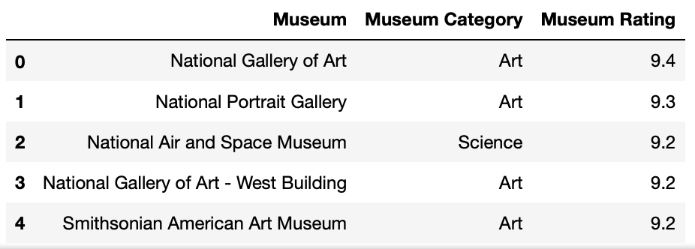

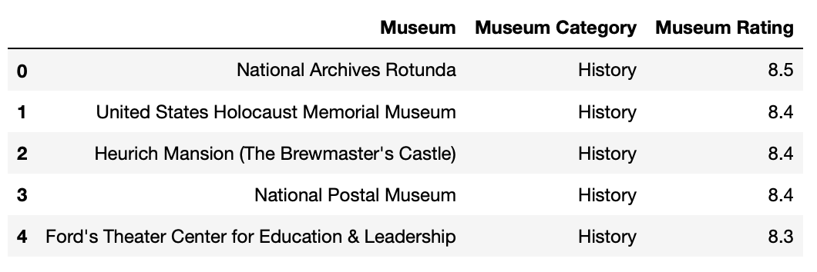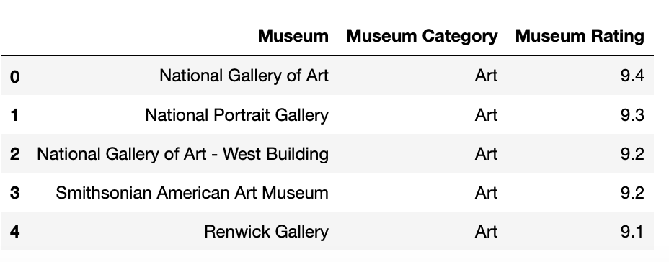Tables 2-5: Top 5 Museums Sorted by Category

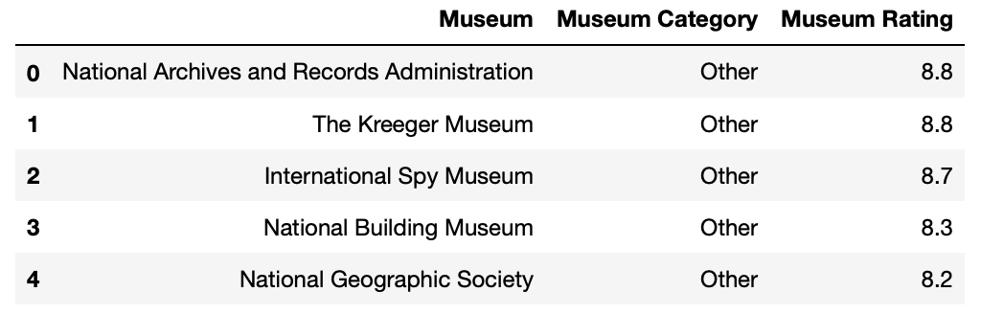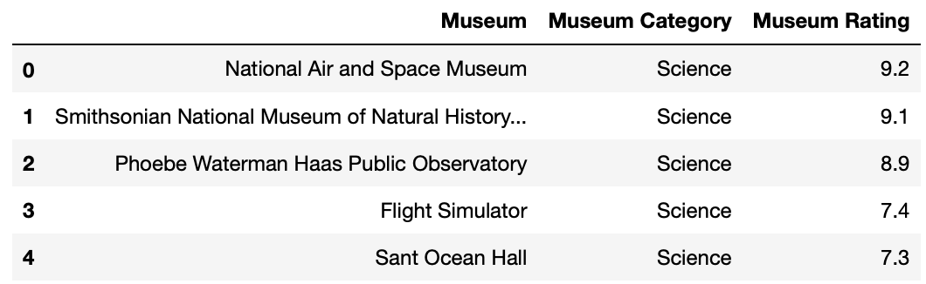

A graph was generated to show the top rankings from each category. *Figure 1* shows that Art museums have the highest ranking (with a top value of 9.4) followed by Science, Other and finally History museums.

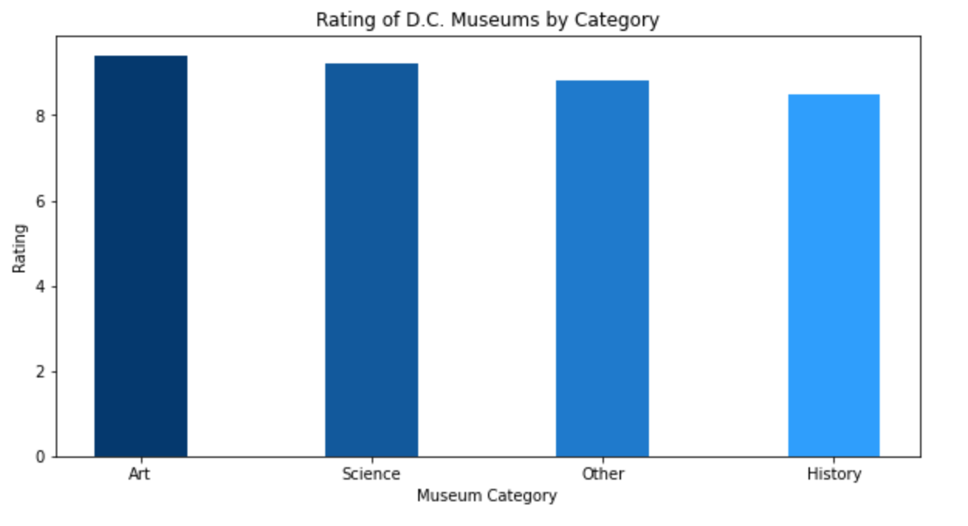

Figure 1: Comparison of Museum Ratings by Category

*Figure 2* shows where each of the museums are located in D.C. The museums are also color coded by category. Science in green, history in purple, art in red, and other in blue. Each museum has a popup label with the name, category, and rating.

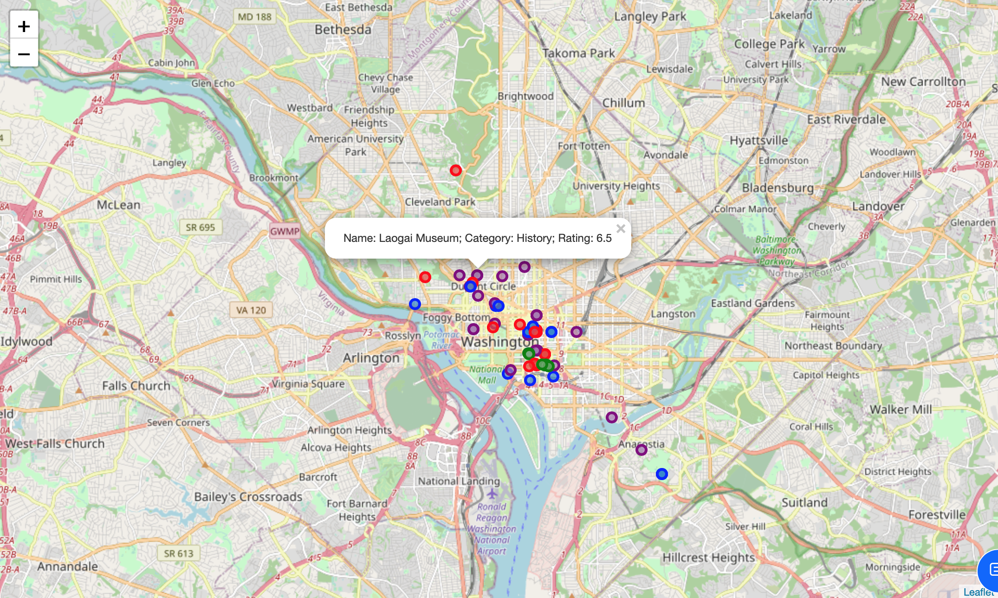

Figure 2: Map of Museums in D.C.

The final map that was generated in shown in *Figure 3*. This map displays the neighborhoods in D.C. and lists the rankings of most popular museum categories.

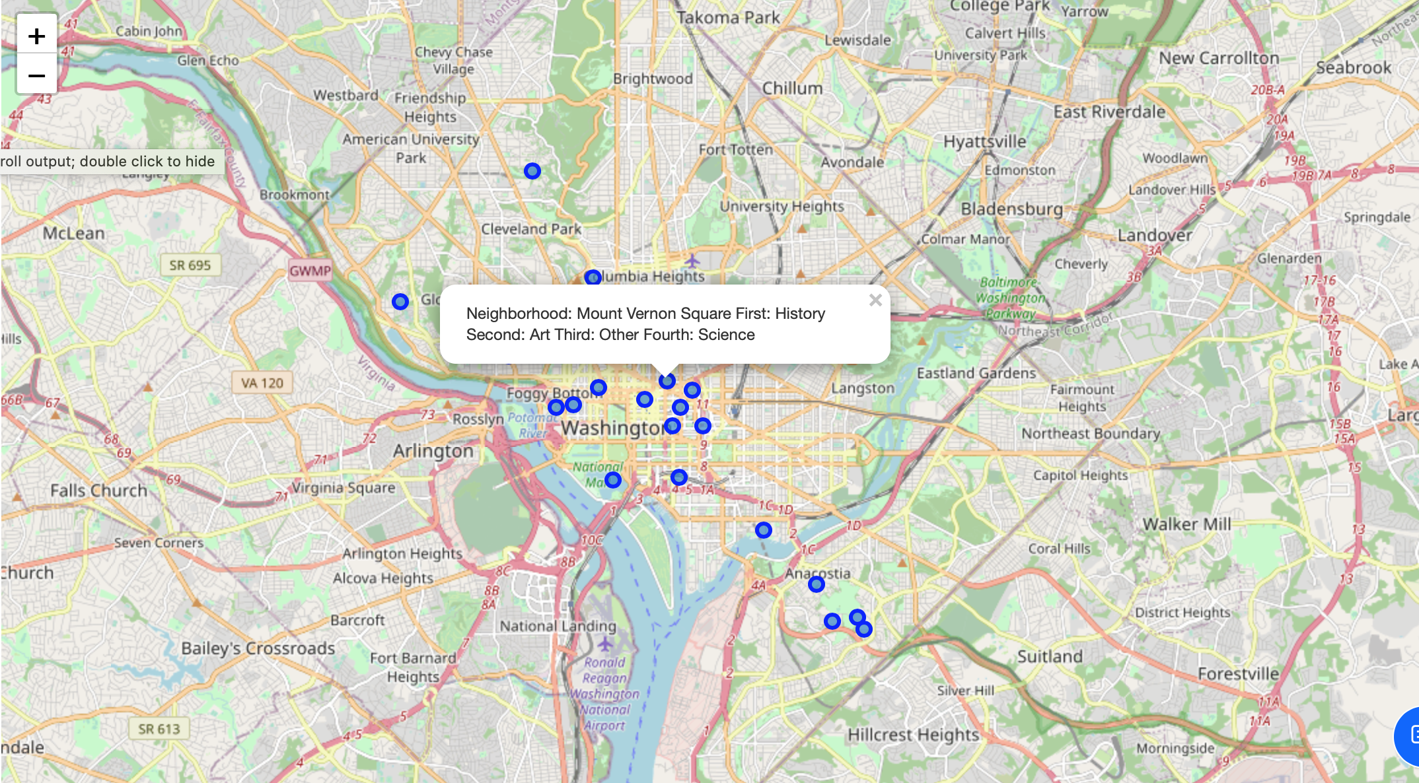

Figure 3: Neighborhoods in D.C. and Museum Rankings

# Discussion

The data in this report shows several findings. First, according to visitors, the best museum to visit in Washington, D.C. is the National Gallery of Art. This art museum isn’t the only good museum, in fact out of all the different types of museums, the art museums in D.C. are the most highly rated.

From the maps generated, we see that a majority of museums are located downtown, right in the heart of the city. It is interesting to note that the history, art, and other museums are a little more dispersed compared to science museums. There is a science “hub” in the Penn Quarter neighborhood of D.C.

If someone was interested in going to museums in D.C. these maps could be of help. First, by showing where the museums are specifically located. Second, by listing rankings of museum categories by neighborhood. This is especially useful if the visitor is looking for museums to visit close to where they are staying. However, it is noticeable that there are several neighborhoods missing from the map as there are no museums near them.

# Conclusion

This project used public data from the government as well as foursquare data to analyze museums in Washington, D.C. Rankings of each museum were generated to provide lists of the top 5 museums overall as well as based on museum category. Maps were made to visualize museum location.